# TITLE PAGE

MID-TERM TEST REPORT

Research on satisfaction of UPH Medan Campus environment



Group 6

PIC 1 : Winnie Felicia (03081220002)

PIC 2 : Daniel Lexandrosth Halim (03081220025)

PIC 3 : Rosita Darianty (03081220014)

PIC 4 : Verrel Angkasa (03081220031)

PIC 5 : Vicky Darmana (03081220038)

|  |  |
| --- | --- |
| **VIDEO** | |
| PIC 1 |  |
| PIC 2 |  |
| PIC 3 |  |
| PIC 4 |  |
| PIC 5 |  |

# ORIGINALITY STATEMENT OF THE THESIS

# THESIS SUPERVISOR’S APPROVAL

# THESIS EXAMINATION COMMITTEE

# ABSTRACT

# ABSTRAK

# ACKNOWLEDGEMENTS

# **TABLE OF CONTENTS**

TITLE PAGE i

ORIGINALITY STATEMENT OF THE THESIS ii

THESIS SUPERVISOR’S APPROVAL iii

THESIS EXAMINATION COMMITTEE iv

ABSTRACT v

ABSTRAK vi

ACKNOWLEDGEMENTS vii

TABLE OF CONTENTS viii

LIST OF TABLES xii

LIST OF FIGURES xiii

LIST OF APPENDICES xiv

CHAPTER I INTRODUCTION 1

1.1 Background of the Study 1

1.2 Statement of the Problem 2

1.3 Purpose of the Study 3

1.4 Research Questions 4

1.5 Significance of the Study 5

1.6 Definition of Terms 6

CHAPTER II LITERATURE REVIEW 7

2.1 Online Learning 7

2.1.1 Traditional vs Online Learning 8

2.1.2 Development of Online Learning 9

2.2 Blended Learning 10

2.3 Theoritical Framework 11

CHAPTER III RESEARCH METHOD 12

3.1 Research Design 12

3.2 Research Setting and Subject 19

3.3 Instruments 20

3.4 Data Collection Procedure 21

3.5 Data Analysis 22

CHAPTER IV RESULTS AND DISCUSSIONS 23

4.1 Quantitative Data Result and Discussions 23

4.2 Qualitative Data Result and Discussions 24

CHAPTER V CONCLUSIONS AND RECOMMENDATIONS 25

5.1 Conclusions 25

5.2 Recommendations 26

5.3 Limitations of the Study 27

Works Cited 28

# LIST OF TABLES

Table 3. 1 Internal Reliability 17

Table 4. 1 Descriptive Statistic 23

# LIST OF FIGURES

Figures 3. 1 Questionaire Screenshot 12

Figures 3. 2 Screenshot 13

Figures 3. 3 Screenshot 13

Figures 3. 4 Screenshot 14

Figures 3. 5 Screenshot 14

Figures 3. 6 Screenshot 15

Figures 3. 7 Screenshot 15

Figures 3. 8 Screenshot 16

Figures 3. 9 Screenshot 16

Figures 3. 10 Screenshot 17

Figures 3. 11 Screenshot 17

Figures 3. 12 Screenshot 18

# 

# LIST OF APPENDICES

*Appendix A kuesioner/test teks* A-1

*Appendix B kuesioner/test responses* B-1

*Appendix C Screen Shoots* C-1

# CHAPTER I INTRODUCTION

## 1.1 Background of the Study

## 1.2 Statement of the Problem

## 1.3 Purpose of the Study

## 1.4 Research Questions

## 1.5 Significance of the Study

## 1.6 Definition of Terms

# CHAPTER II LITERATURE REVIEW

## 2.1 Online Learning

Fasilitas UPH sangat bagus dalam mendukung pembelajaran mahasiswa/i UPH Kampus Medan. (Angkasa, 2023)

### 2.1.1 Traditional vs Online Learning

### 2.1.2 Development of Online Learning

UPH memiliki berbagai fasilitas yang sangat bagus. (Darmana, 2023)

## 2.2 Blended Learning

## 2.3 Theoritical Framework

# CHAPTER III RESEARCH METHOD

## 3.1 Research Design

Figures 3. 1 Questionaire Screenshot

Figures 3. 2 Screenshot

Figures 3. 3 Screenshot

Figures 3. 4 Screenshot

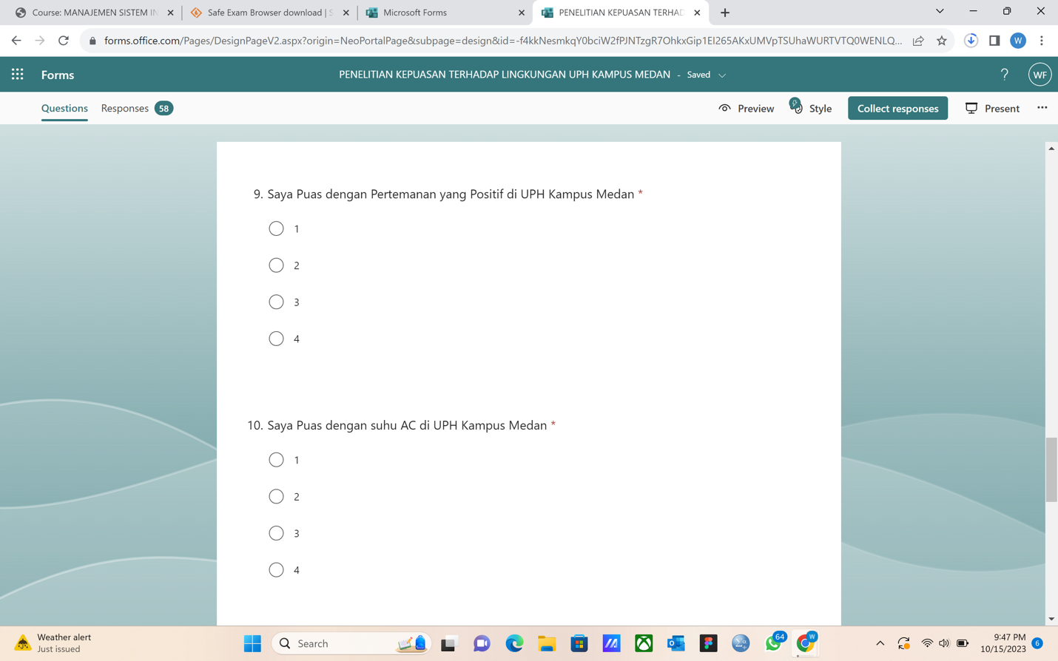

Figures 3. 5 Screenshot

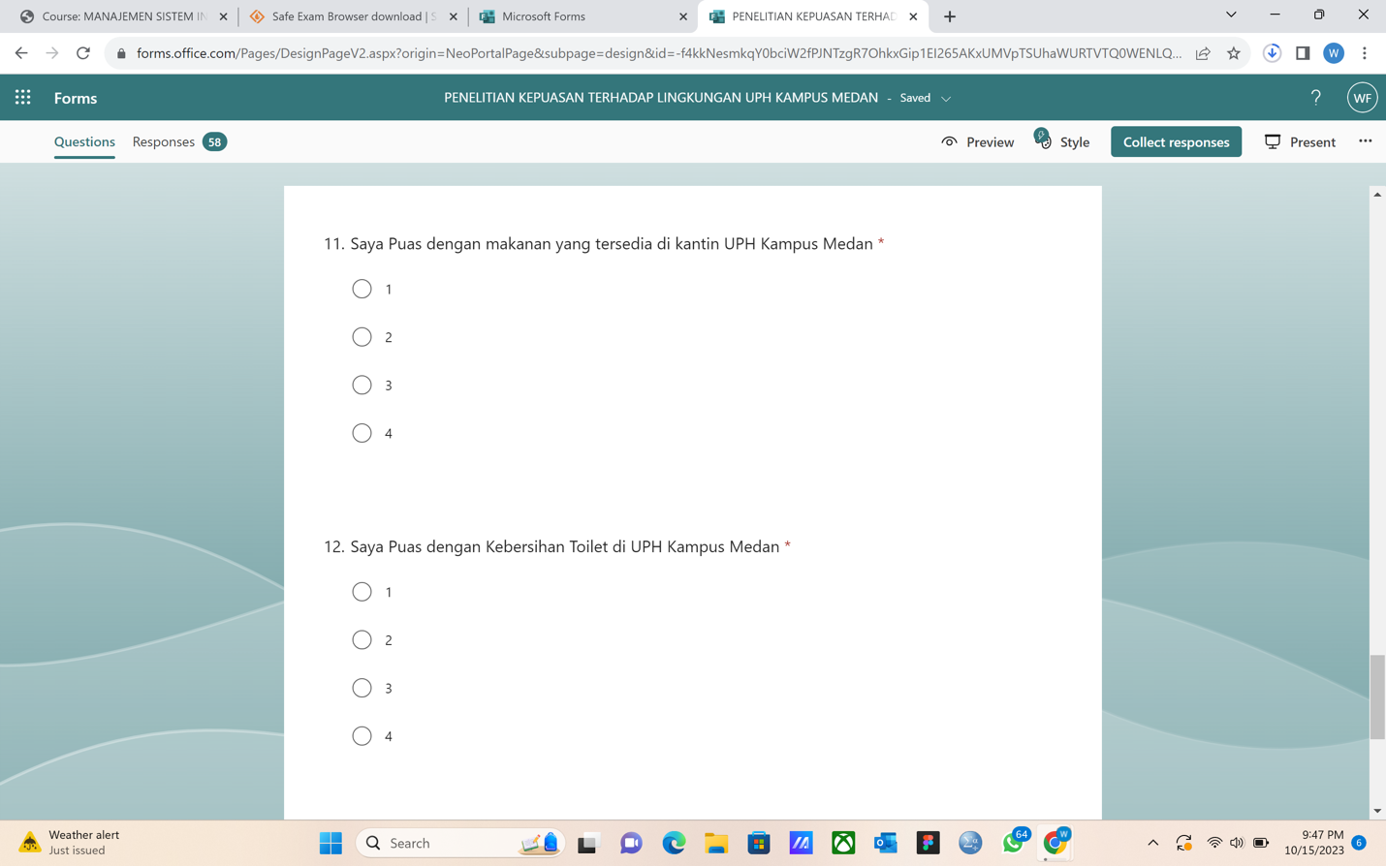

Figures 3. 6 Screenshot

Figures 3. 7 Screenshot

Figures 3. 8 Screenshot

Figures 3. 9 Screenshot

## 

Figures 3. 10 Screenshot

Figures 3. 11 Screenshot

Figures 3. 12 Screenshot

## 3.2 Research Setting and Subject

## 3.3 Instruments

## 3.4 Data Collection Procedure

## 3.5 Data Analysis

Table 3. 1 Internal Reliability

|  |  |
| --- | --- |
| **Cronbach’s Alpha** | **Number of Items** |
| **0,856700337** | **55** |

# CHAPTER IV RESULTS AND DISCUSSIONS

## 4.1 Quantitative Data Result and Discussions

Table 4. 1 Descriptive Statistic

|  |  |
| --- | --- |
| Descriptive Analysis | |
| Mean | 32 |
| Standart Error | 0,635641726 |
| Median | 31 |
| Mode | 30 |
| Standart Deviation | 4,714045208 |
| Sample Variance | 22,222 |
| Kurtosis | -0,378529028 |
| Skewness | 0,016510276 |
| Range | 19 |
| Minimum | 21 |
| Maximum | 40 |
| Sum | 1760 |
| Count | 55 |
| Largest(1) | 40 |
| Smallest(1) | 21 |
| Confidence Level (95%) | 1,274384931 |

## 4.2 Qualitative Data Result and Discussions

# CHAPTER V CONCLUSIONS AND RECOMMENDATIONS

## 5.1 Conclusions

## 5.2 Recommendations

## 5.3 Limitations of the Study

# Works Cited

Angkasa, V. (2023, October 16). *Fasilitas UPH*. Retrieved from uphmedan.co.id: https://www.fasilitasUPH.com

Darmana, V. (2023, October 10). *Nilai Fasilitas UPH*. Retrieved from oneuph.com: https://www.nilaifasiluph.com

*Appendix A kuesioner/test teks*

#### & link

Click [here](https://forms.office.com/pages/responsepage.aspx?id=-f4kkNesmkqY0bciW2fPJNTzgR7OhkxGip1EI265AKxUMVpTSUhaWURTVTQ0WENLQTZITVpEQTYyNi4u&origin=lprLink) to see the online questionnaire.

The questionnaire text:

|  |  |  |  |  |
| --- | --- | --- | --- | --- |
| **Questionnaire** | | | | |
| Saya puas dengan fasilitas dan layanan di UPH Kampus Medan | 1 | 2 | 3 | 4 |
| Saya puas dengan pengajaran dosen di UPH Kampus Medan | 1 | 2 | 3 | 4 |
| Saya puas dengan aktivitas non-akademik di UPH Kampus Medan | 1 | 2 | 3 | 4 |
| Saya puas dengan kegiatan belajar mengajar di UPH Kampus Medan (Akademik) | 1 | 2 | 3 | 4 |
| Saya puas dengan interaksi dosen dengan mahasiswa di UPH Kampus Medan | 1 | 2 | 3 | 4 |
| Saya puas dengan pertemanan yang positif di UPH Kampus Medan | 1 | 2 | 3 | 4 |
| Saya puas dengan suhu AC di UPH Kampus Medan | 1 | 2 | 3 | 4 |
| Saya puas dengan makanan yang tersedia di kantin UPH Kampus Medan | 1 | 2 | 3 | 4 |
| Saya puas dengan kebersihan toilet di UPH Kampus Medan | 1 | 2 | 3 | 4 |
| Saya puas berkuliah di UPH Kampus Medan | 1 | 2 | 3 | 4 |

#### responses

*Appendix B kuesioner/test responses*

Click [here](https://uph365-my.sharepoint.com/:x:/g/personal/03081220002_student_uph_edu/EdRX1trH9nhEuZ9kh8T-lXEBH9DRY-cHdz3jW61egMDULw?e=mB4snx) to see the responses.

*Appendix C Screen Shoots*

